**Project Story**

**Student Enrollment & Satisfaction Analysis**

**Project Introduction**

This project analyzes student enrollment data from Regional Community College to identify insights about students, courses, and professors. The goal is to improve professor evaluations while keeping course costs under control.

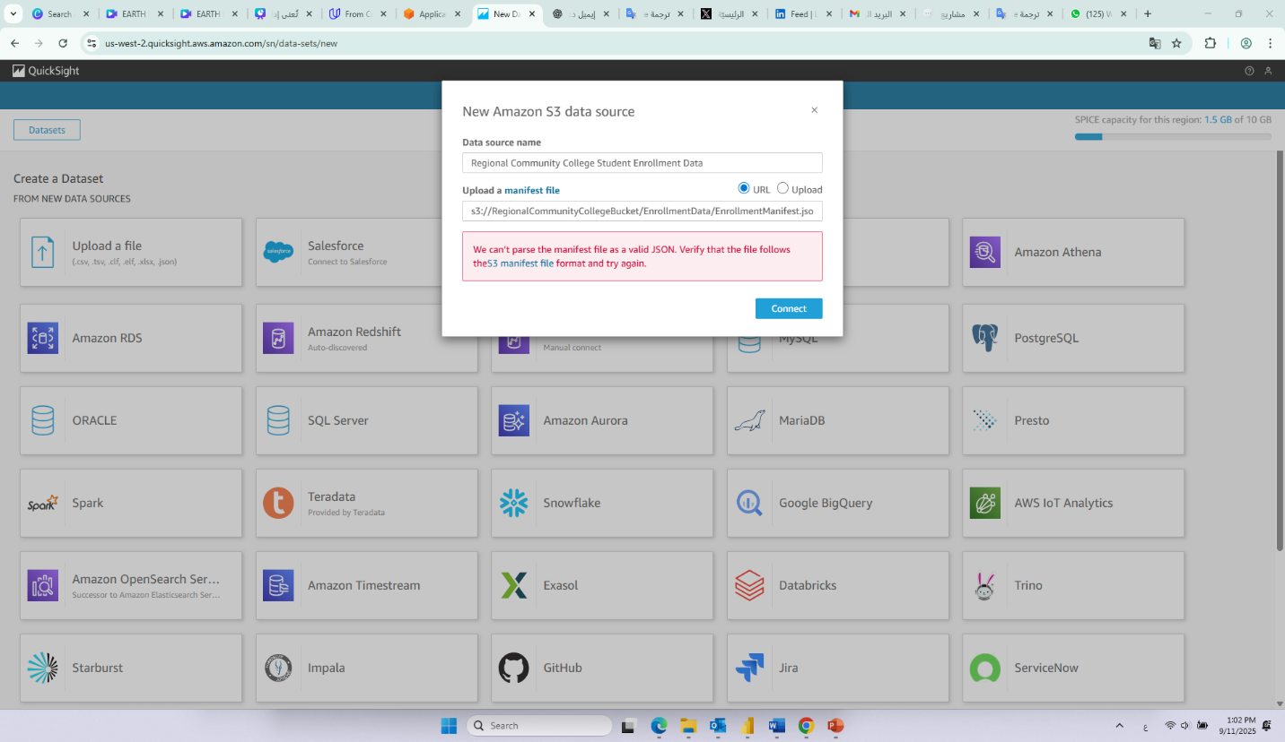

Attempted to create dataset Regional Community College Student Enrollment Data using manifest s3://RegionalCommunityCollegeBucket/EnrollmentData/EnrollmentManifest.json. QuickSight returned an access/bucket-not-found error *screenshot attached*. Canceled creation and confirmed dataset not present in Datasets list.

**Dataset Preparation**

-Renamed ‘HomeOfOrigin’ to ‘NationalOrigin’ with clear description.

-Added calculated field ‘Student Type’ (Youth vs. Adult Continuing Education).

-A weekly update schedule has been set for the Dataset, starting at 12:00 AM next Sunday, taking into account the local time zone.

**Initial Analysis (Student Body Overview)**

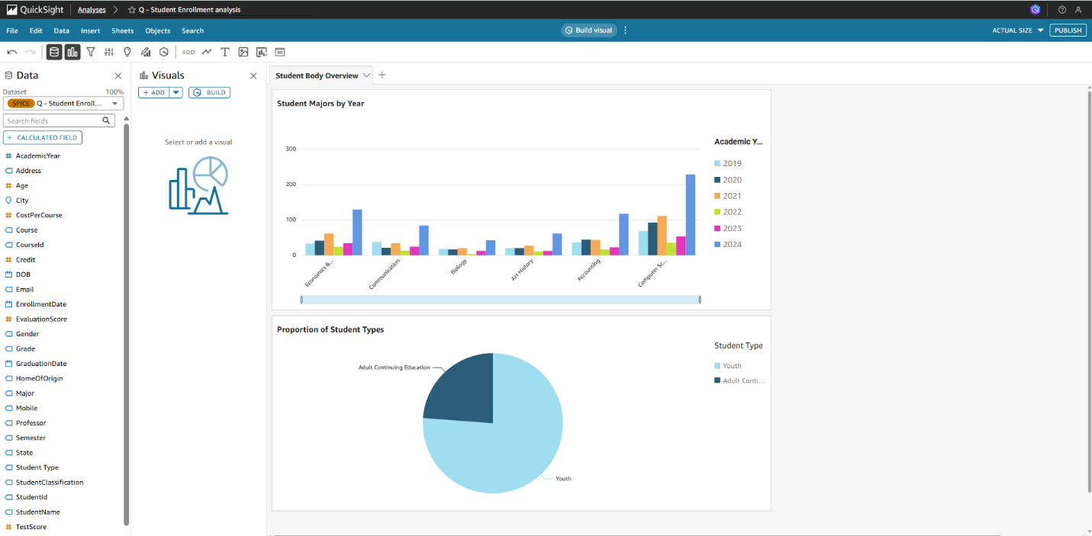**-Visual 1:** “Student Majors by Year” shows distribution of students by major and academic year.

**-Visual 2:** “Proportion of Student Types” compares Youth vs. Adult Continuing Education.

➡ Together, these visuals provide a clear overview of the student body demographics.

**Topic & Verified Questions**

-Created a new “Topic: Regional Community College Student Data”.

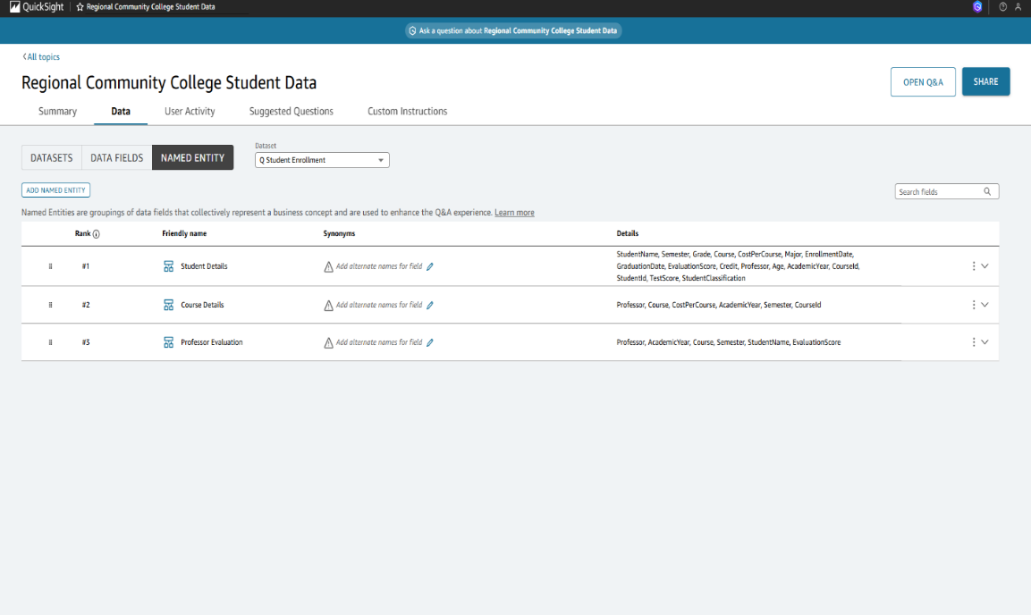-Defined Named Entities: Student Details, Course Details, Professor Evaluation.

-Verified key business questions, such as:

**Q1.**Which professors have the best evaluations?

**Q2.**Which courses are the most expensive??

**Named Entities**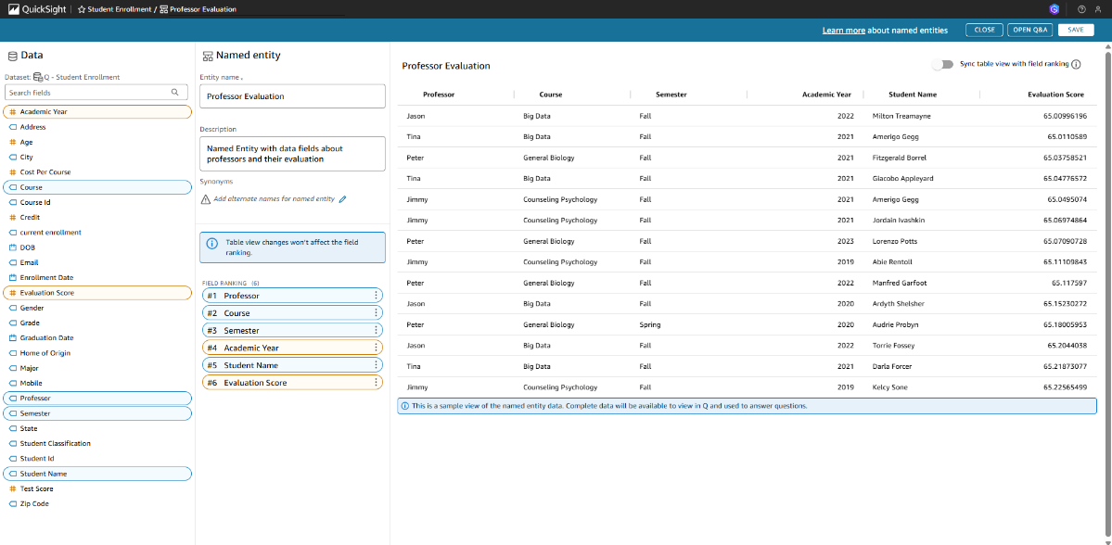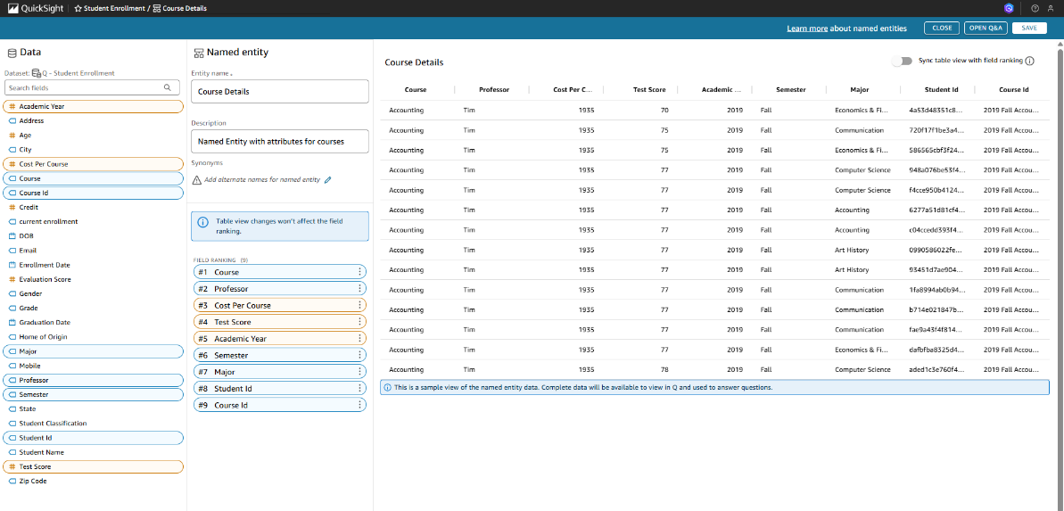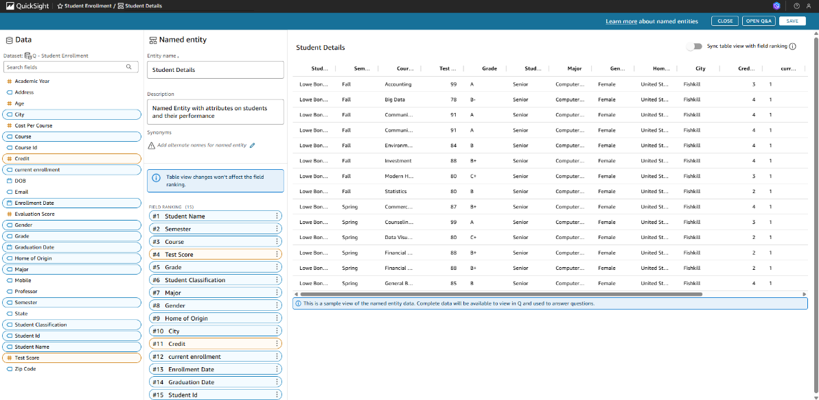

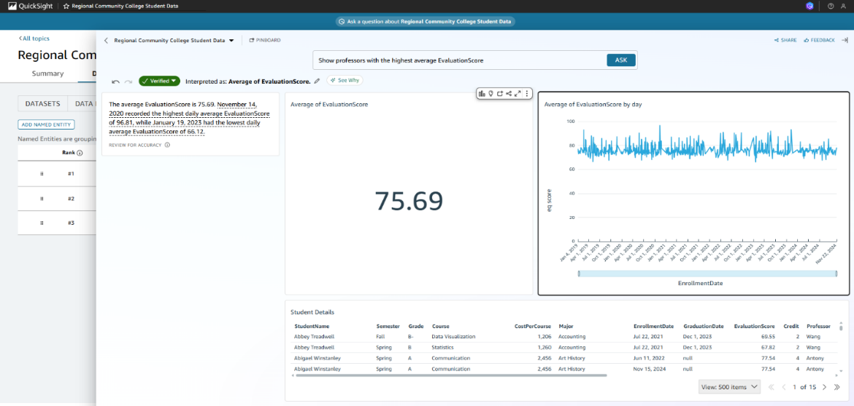Using QuickSight Q, verified answers were obtained for key questions: **'Which instructors got the best average evaluations?**' and **'Which courses are the most expensive?**'. Each answer was carefully checked for accuracy, ensuring that the results reflect the highest average evaluation scores and the highest course costs, and then marked as Verified for reliability in further analysis and dashboards.

The 'Improving Student Satisfaction Without Increasing Costs' scenario was created using all relevant dashboard visuals. The starter question and a series of follow-up questions (Threads) were added to explore factors affecting professor evaluation scores and to develop actionable recommendations.

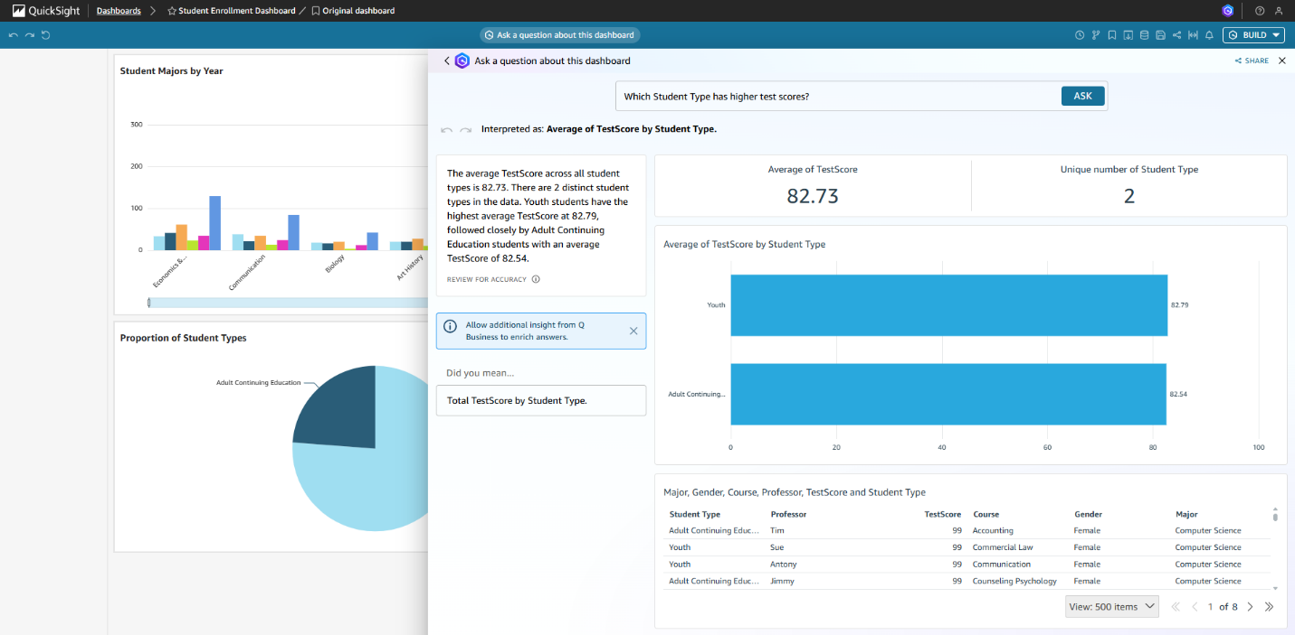

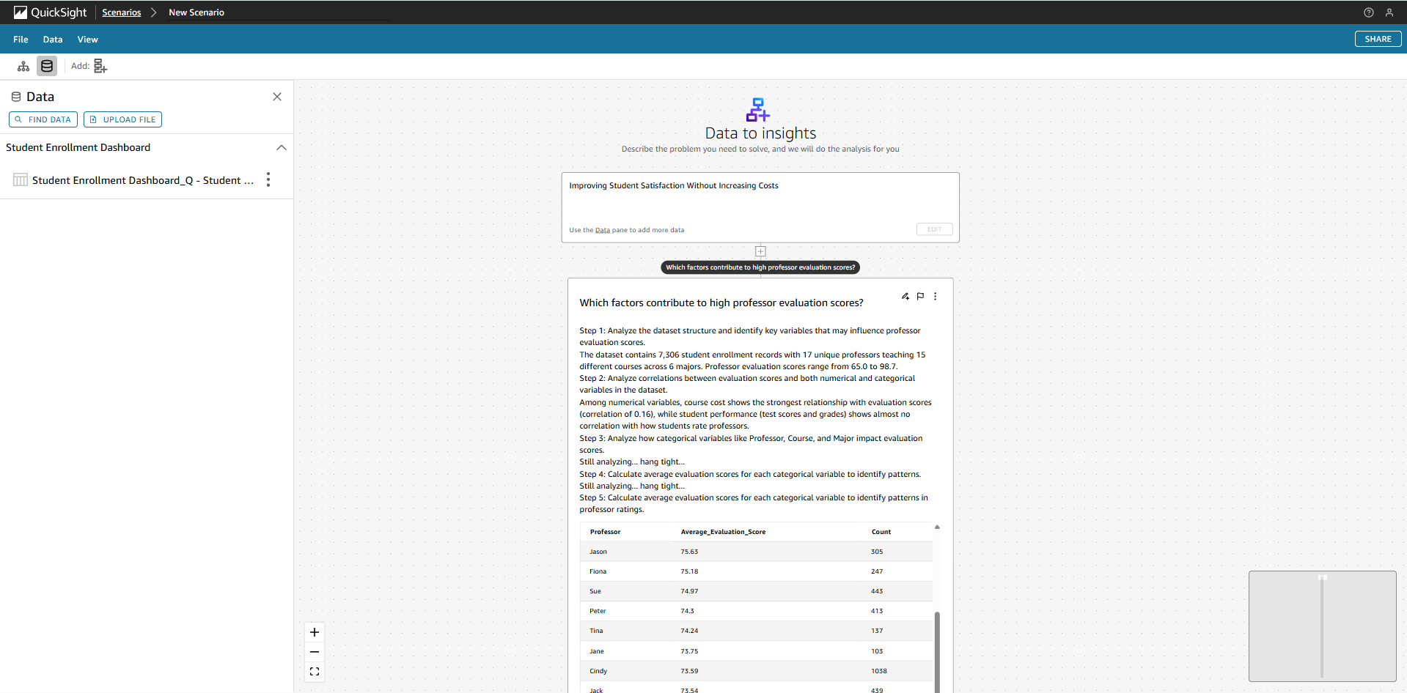

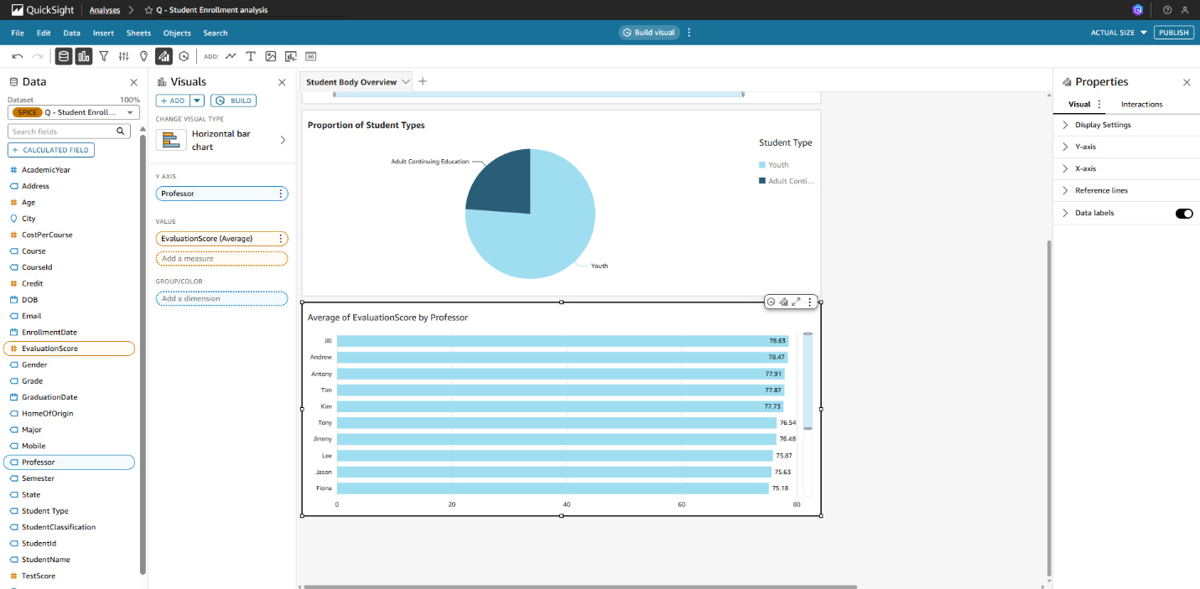**Extended Analysis & Scenarios**

* Additional visuals created:

-Professors with best evaluations

-Courses with best evaluations

-Professors with highest costs

-Courses with highest costs

-Built scenario: “Improving Student Satisfaction Without Increasing Costs”

➡ This step allowed multi-step reasoning with follow-up questions to explore data.

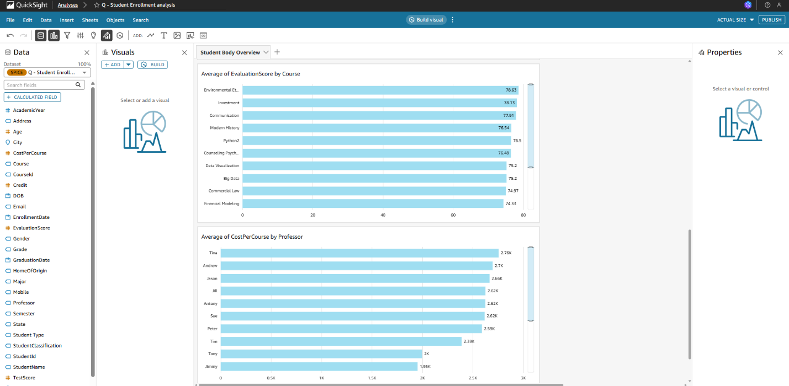

**Dashboard Screenshot**

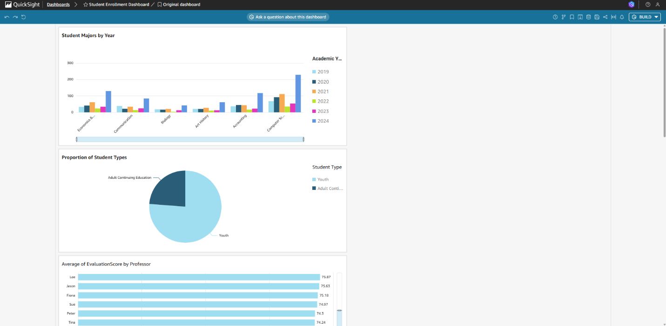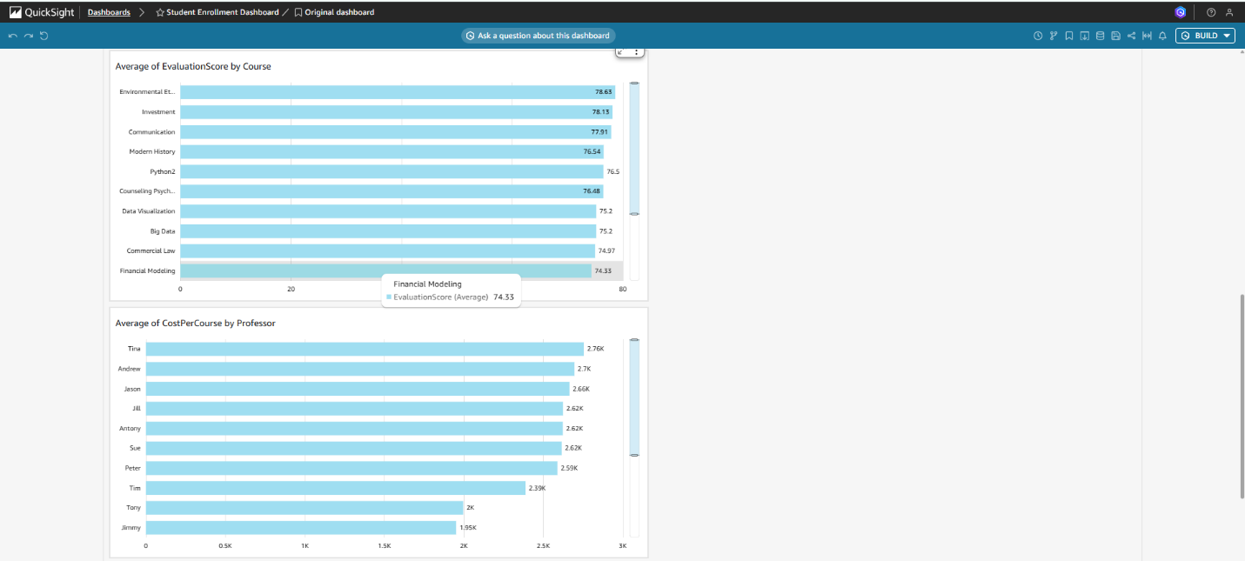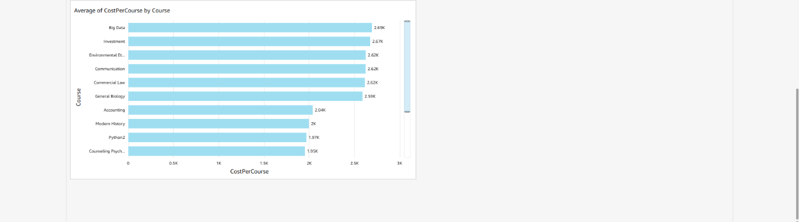

**Data Story Conclusion**

* Focus on “professors with high evaluation scores” and share best practices across faculty.
* Avoid increasing costs by reallocating teaching resources instead of raising course prices.
* Monitor correlations between “course costs and student satisfaction” to ensure balance.
* Invest in targeted training for professors teaching high-demand but lower-rated courses.

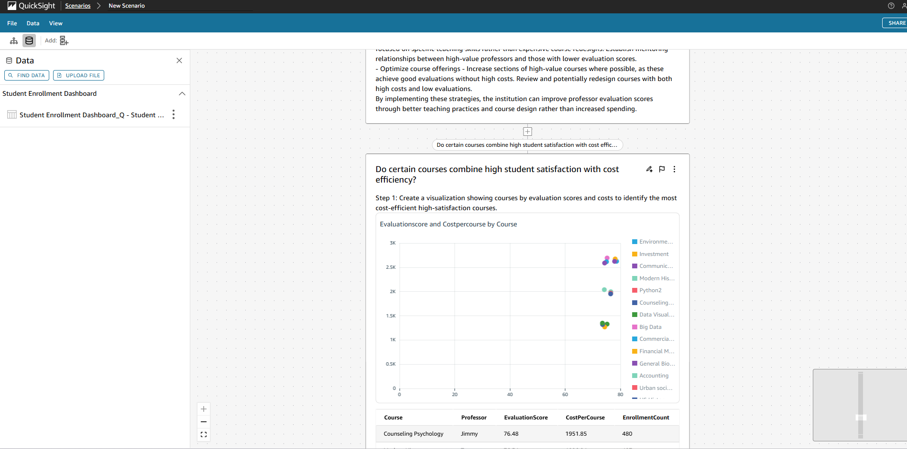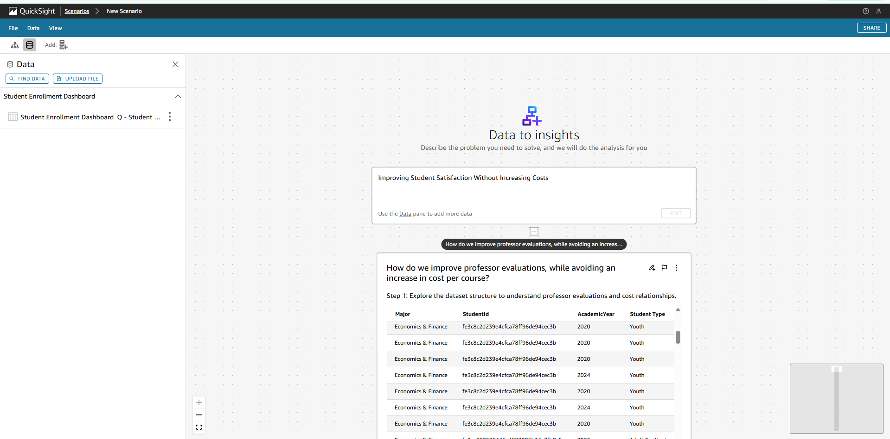

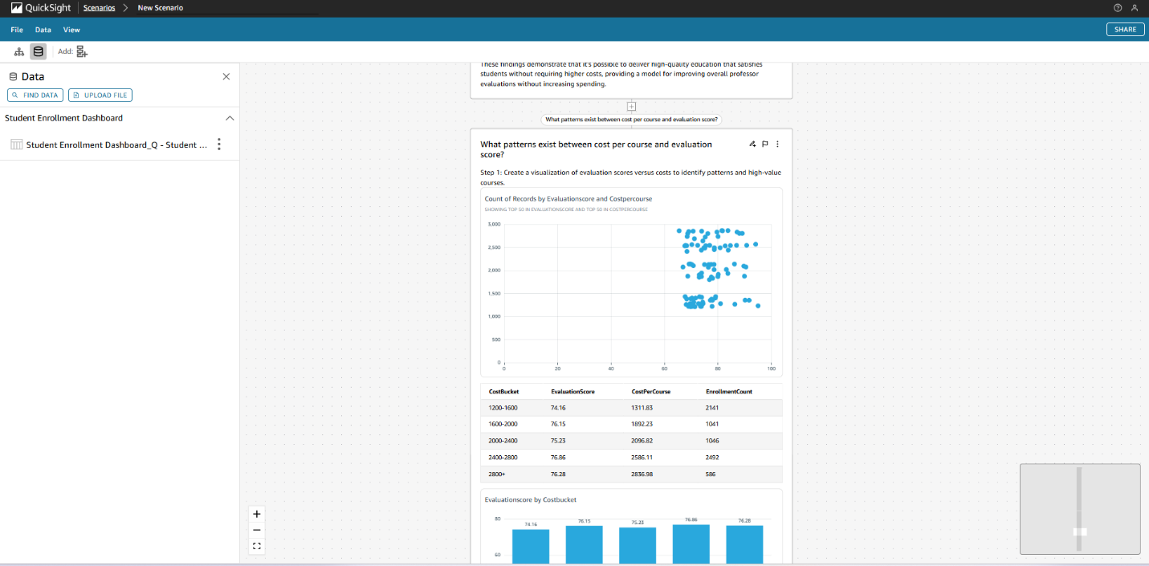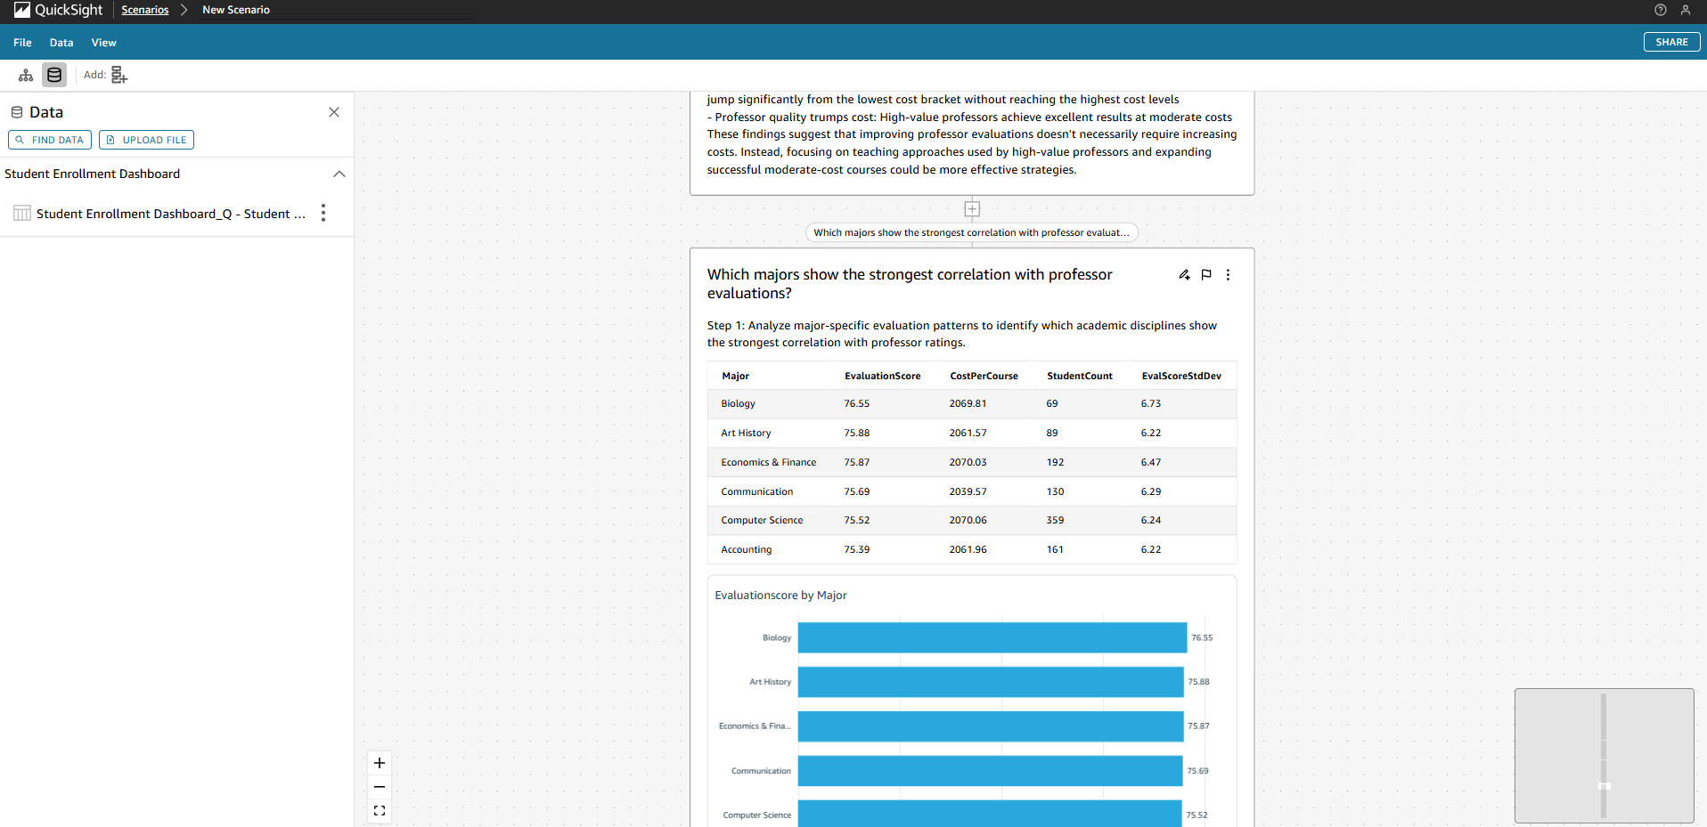

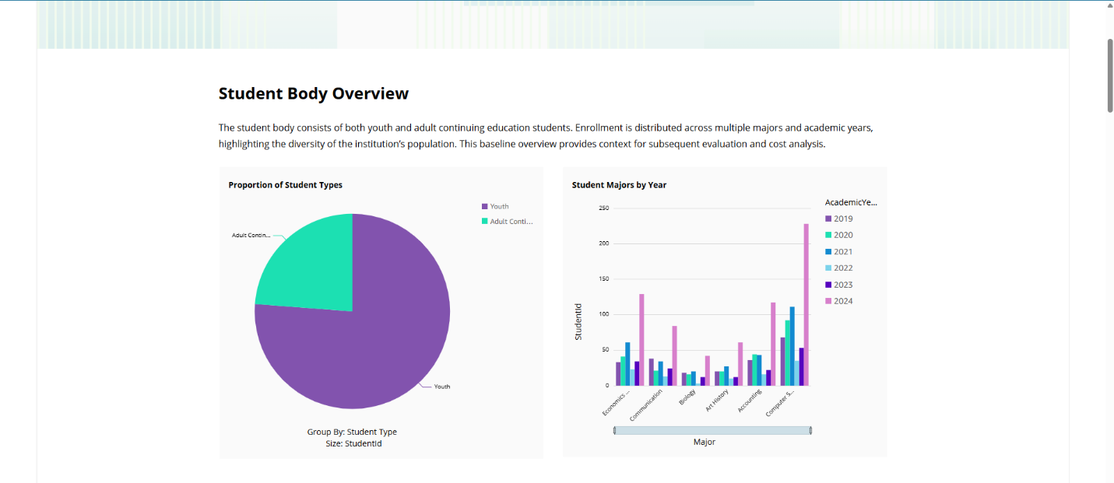**Data Storytelling using Q in QuickSight**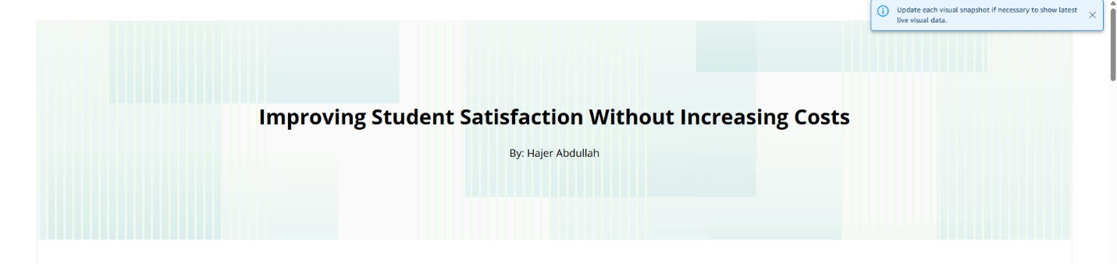

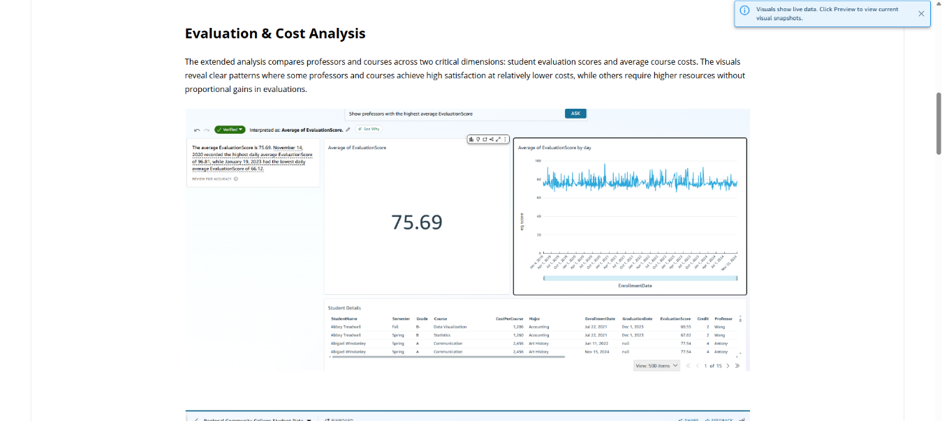

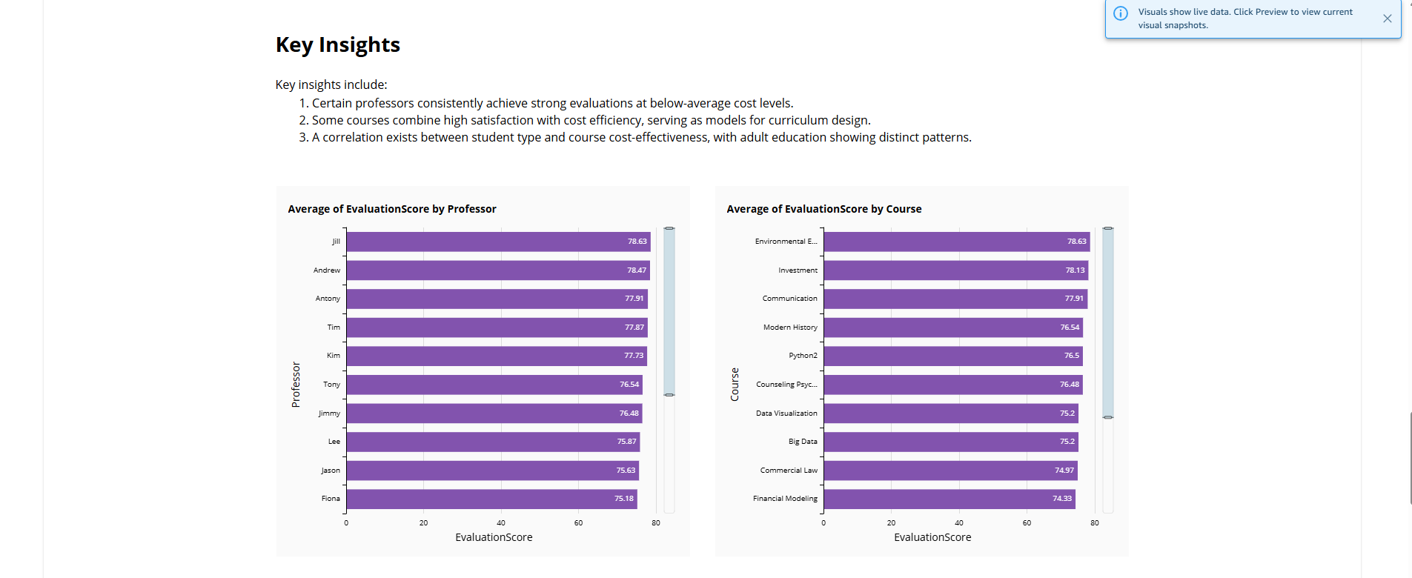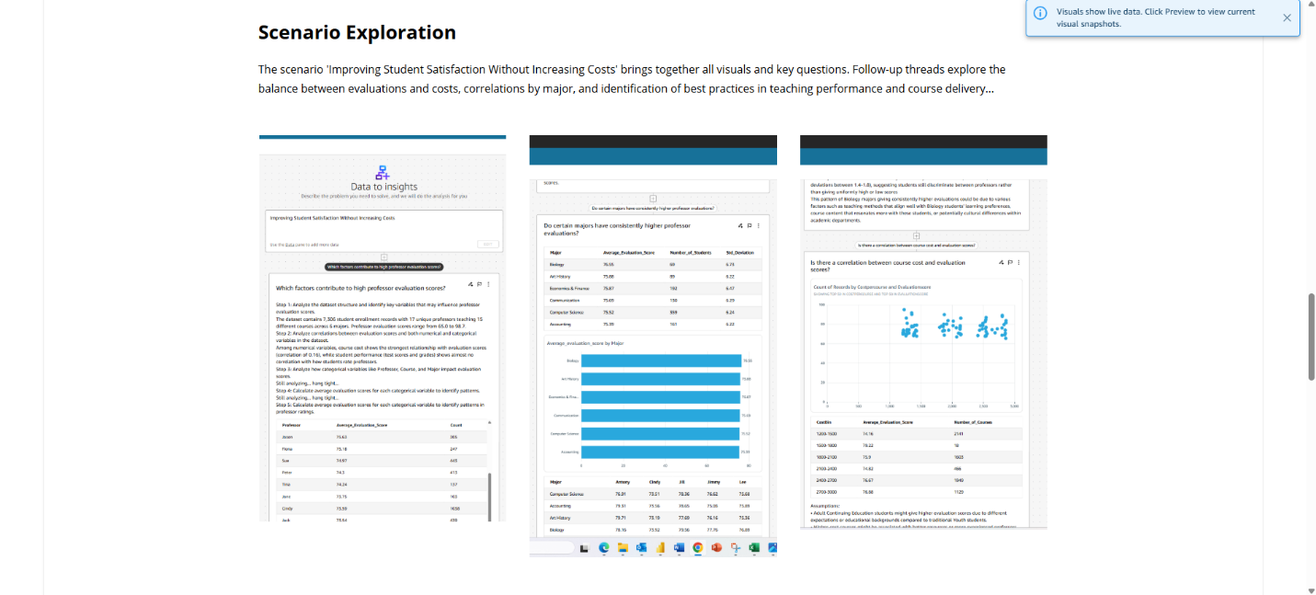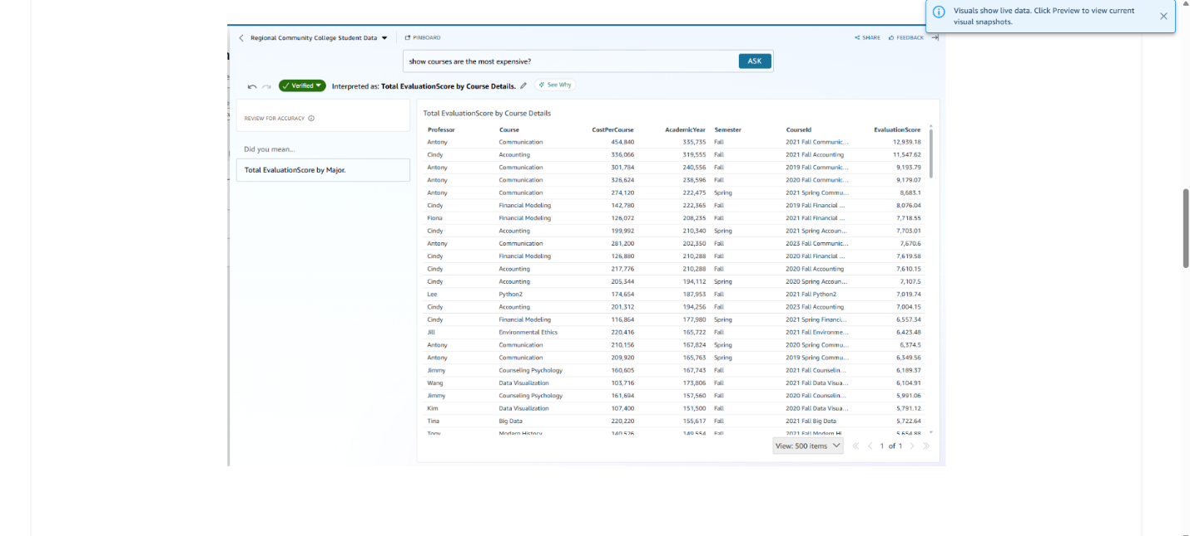

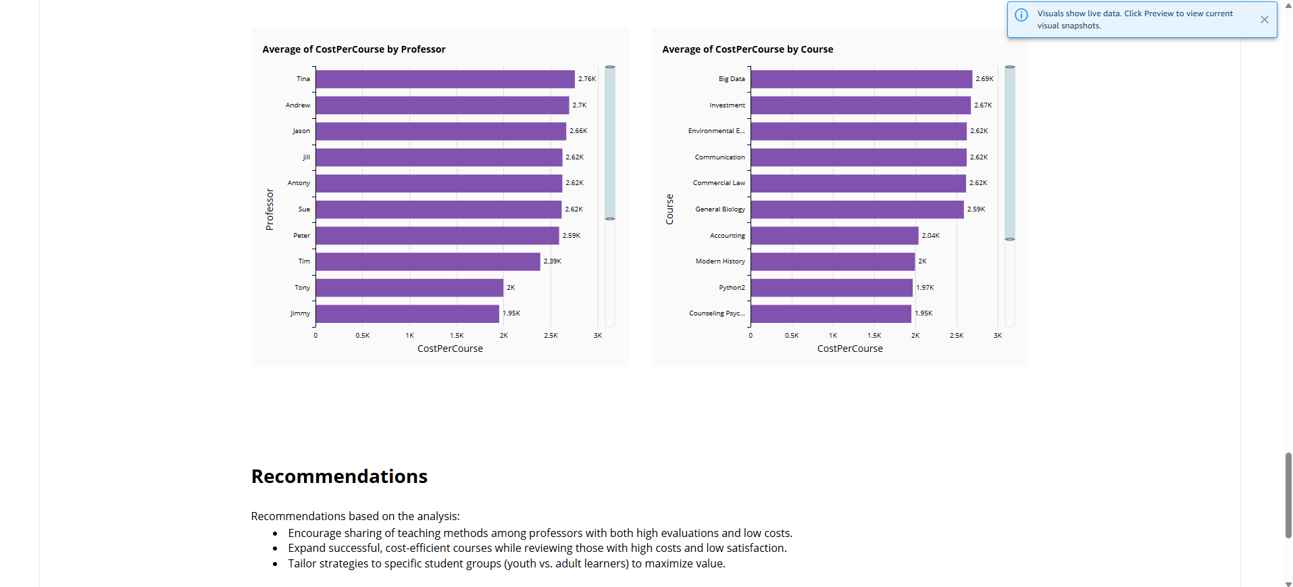

**Summary**

This project demonstrates how Amazon QuickSight can be used to prepare data, generate insights, verify business questions, and create interactive scenarios. The final Data Story connects data to actionable recommendations for the college’s leadership.

**Conclusion & Project Link**

This project provided me with valuable hands-on experience in preparing datasets, building analyses, and creating data stories using Amazon QuickSight. The step-by-step process enhanced my understanding of how to transform raw data into meaningful business insights and actionable recommendations.

For further review and exploration, the project can be accessed using the following link:

[ [Click Here](https://us-west-2.quicksight.aws.amazon.com/sn/stories/8a402c22-753f-4f31-aee7-af0350c7aa4e/view) ].

Submitted By: Hajer Abdullah.

Date: 18 Sep 2025